   Create a class Customer with the following specifications. Private Members : Customer_no ,Customer_name,  Qty ,  Price, TotalPrice, Discount, Netprice. Methods: Public members: 1. A parameterized constructor to assign 2. Input( ) – to read data members. Call Caldiscount().  3. Caldiscount ( ) – To calculate Discount according to TotalPrice and NetPrice . TotalPrice = Price   TotalPrice >=50000 – Discount 25% of TotalPrice Netprice=TotalPrice-Discoun  4.  
Show( ) – to display Customer details.                       
Develop a Java program to accept details of n  
customers, calculate the discounts given to them and print their complete  
details.

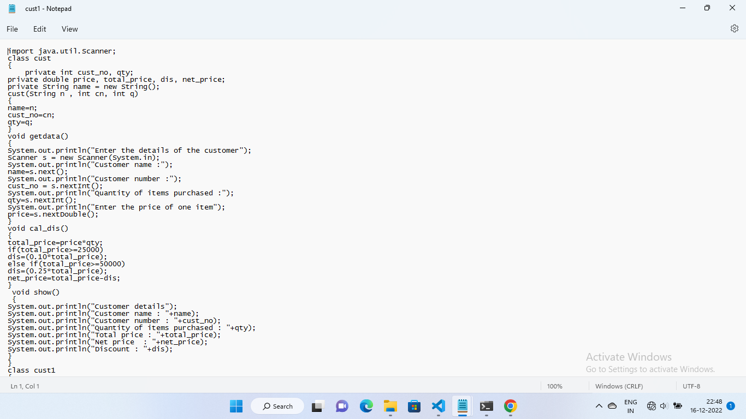

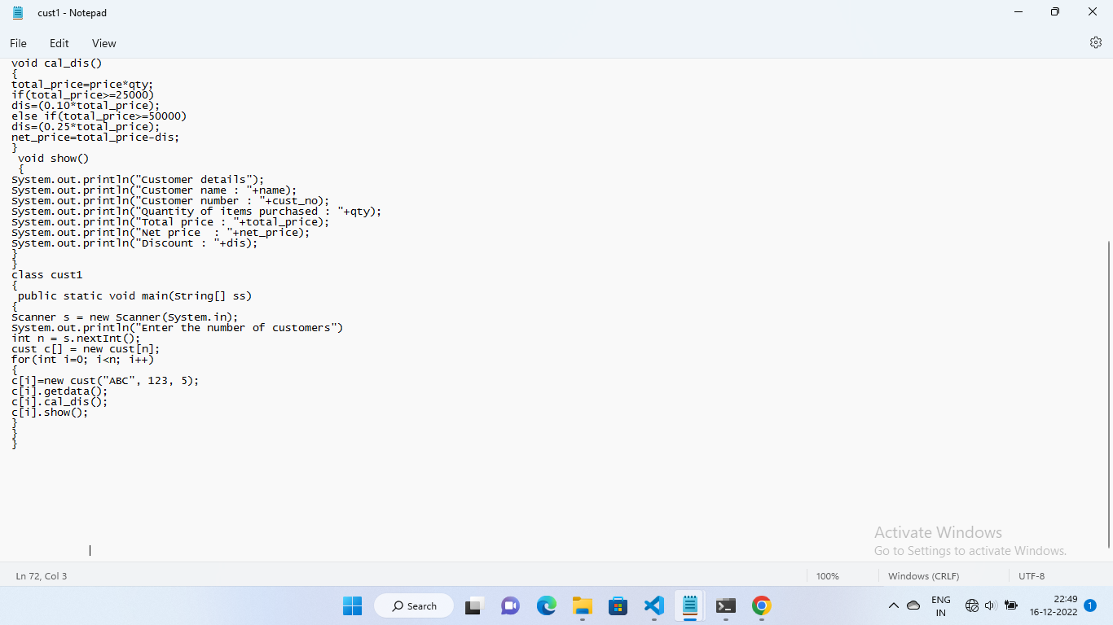

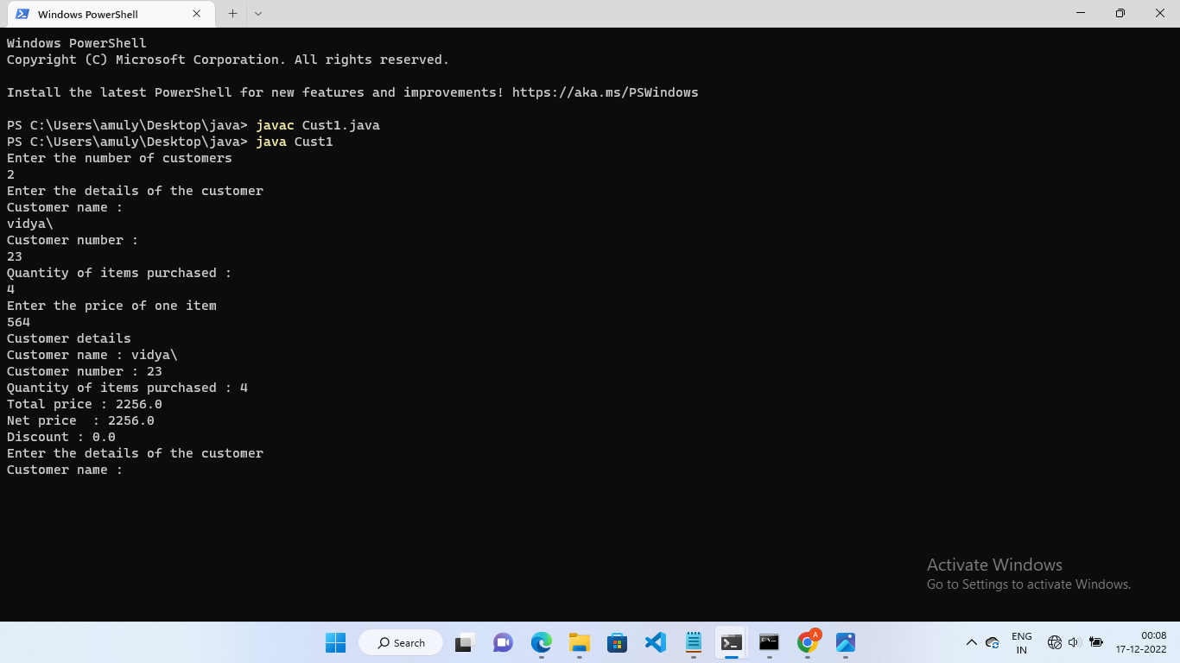

2.      
Develop a Java program to create a class Patient with data members pt_id, pt_name, pt_age, doc.  
 The program should include the following functionalities. Accept n patient details. Accept  
a patient id and display his/her details. Accept the name of the doctor and display the names of all the patients treated  him/her.

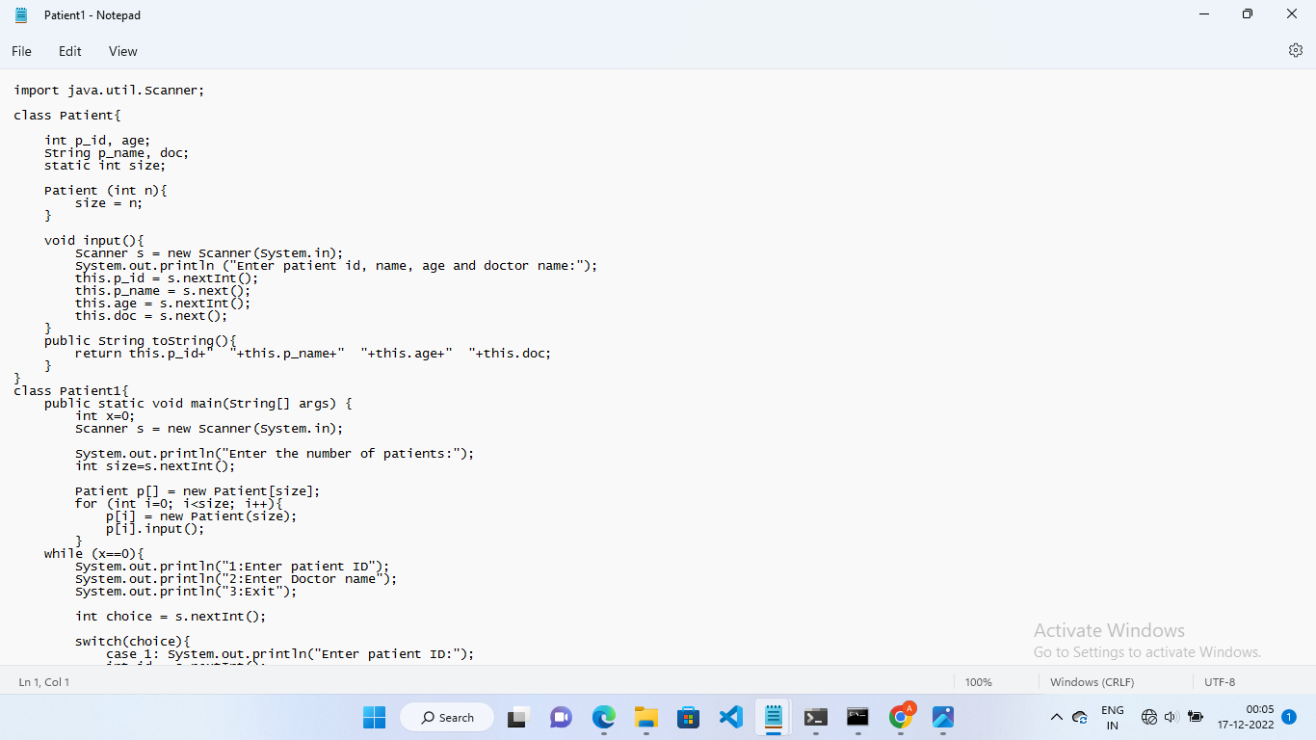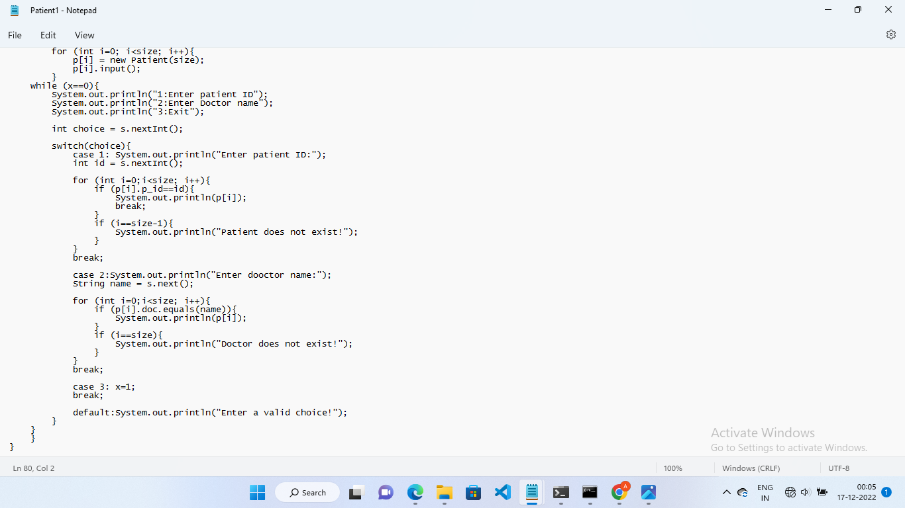

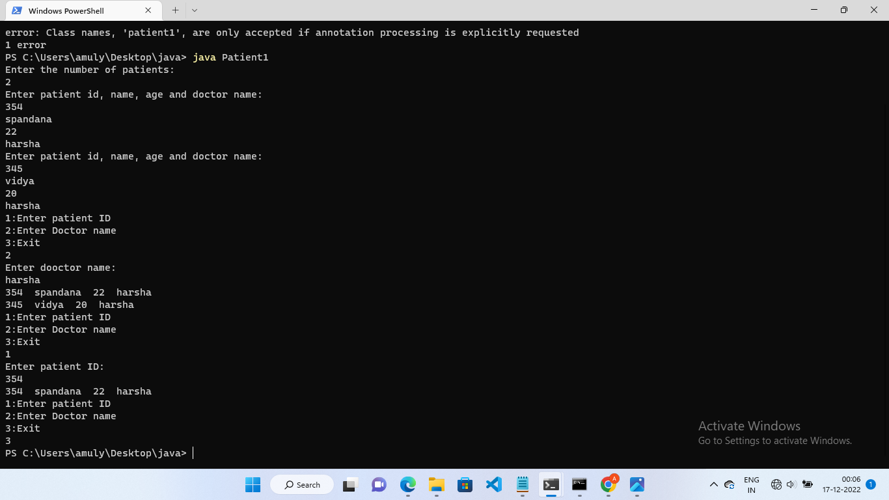

|  |
| --- |
| 3.     Create an abstract class Calculate which has three double members -say x,y an result. Include a method calc. Derive three classes from Calculate which performs any three arithmetic operations on the two variables x and y and assign the result to the variable result. Make appropriate declarations and definitions. |
|  |
|  |
|  |

  
  
